2022-2023 SHIRT ORDER FORM

Proceeds will benefit the Department President & Commander's Special Project
Minnesota Assistance Council for Veterans
(Eliminating Veteran Homelessness)

Red Polo Shirt with Eagle Logo

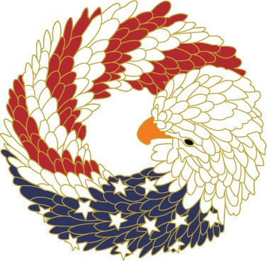

ONE SHIRT PER ORDER FORM

All SHIRTS ARE $20 EACH - NO MATTER THE SIZE

Size *** Please note - ladies run small - Suggest ordering one size up

Ladies _______ Available in Small - 2X L

Men's ________ Available in Small - 5XL

You can pick up your shirt at Fall Conference or Mid-Winter
Order deadline is August 15

Name: _________________________________ Auxiliary # ______
Address: _______________________________ District # _______
City, State Zip: ______________________________________________
Phone: ______________ Cash: ________ Check #: _________

** Mail form to: VFW Auxiliary, 20 W. 12th St. 3rd Floor, St. Paul MN 55115

