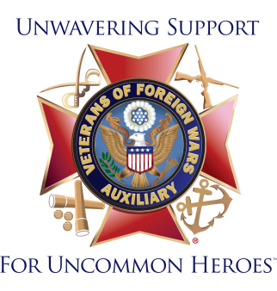
Facebook Posts for Member Recruitment
Post #1:
If you’re not a member of our organization and are a relative of someone who served overseas in a location of foreign conflict, we invite you to join us as we work to improve the lives of veterans, service members, their families and our communities. Join us and honor your veteran and those who protect and serve. Click here to join now or learn more! www.vfwauxiliary.org
Post #2:
Help veterans and service members in our community! If you are a relative of someone who served in a location of foreign conflict, we invite you to join us and honor your veteran and those who protect and serve. Click here to join now or learn more! www.vfwauxiliary.org
Post #3:
You may know I am a member of the VFW Auxiliary, but do you know what our great organization does to help veterans in our community? We visit veterans in VA hospitals, nursing homes and veterans homes. We lay wreaths on the graves of America’s heroes on Memorial Day and Veterans Day. We visit schools and educate our town’s youth about patriotism and the American Flag. And, we offer scholarships! These are just some of the ways the VFW Auxiliary is active in our local community. If you’re a relative of a veteran who served in a location of foreign conflict and are interested in joining me in any of these activities, contact me and I’ll be happy to speak with you about my involvement in the VFW Auxiliary. You may also visit the national website at www.vfwauxiliary.org.
Post #4:
The VFW Auxiliary wants YOU to join us as we serve the veterans of this country and our communities in honor of the sacrifices and commitment of every man and woman who has served in uniform. If you’re the relative of someone who served in a location of foreign conflict, we invite you to learn more about what we do and how we help veterans, service members, their families and our communities. Click here to find out more about the VFW Auxiliary today! www.vfwauxiliary.org
Post #5:
The VFW Auxiliary is one of the nation’s oldest veterans’ service organizations and our members are the relatives of those who served in a location of foreign conflict. We have nearly 470,000 members representing all 50 states who volunteer millions of hours and give millions of dollars to support veterans, military service personnel and their families.
We are a voice for veterans on Capitol Hill and are instrumental in assisting the VFW pass or block legislation that impacts veterans and their families. We are one of the top 10 providers of volunteer hours in the VA medical system. Every year, members fundraise millions of dollars for charitable projects that benefit veterans and their families. We also provide hundreds of thousands of dollars in scholarships for our nation’s youth. With more than 3,600 Auxiliaries, there is likely one in your area working to improve the lives of America’s uncommon heroes. Learn more at www.vfwauxiliary.org.

