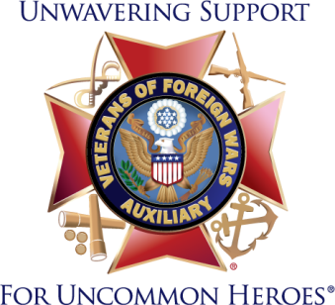
2020-2021 Local Talking Points
- Established in 1914, the VFW Auxiliary is the nation’s oldest veterans’ service organization auxiliary.
- Members of the VFW Auxiliary are the relatives of those who have served in overseas combat.
- There are nearly a half million members representing all 50 states. We have _____ members in (list your state or Auxiliary).
- We serve the veterans of this country and our communities in honor of the sacrifices and commitment of every man and woman who has served in uniform.
- It is our mission to assist the VFW in any way we can. We share a common goal of serving veterans, their families and our communities.
- During the 2019-2020 Program Year, Auxiliaries provided a total 3 million dollars in aid to veterans, military service members and their families.
- Some of the ways members offer support are:
  - By being a voice for veterans, locally and on Capitol Hill; we are instrumental in assisting the VFW pass or block legislation that impacts veterans and their families.
  - By assembling and mailing care packages to active-duty troops.
  - Holding send-off and welcome-home events for troops.
  - Spreading the word about PTS and military/veteran suicide awareness.
  - Participating in Stand-Downs and assisting homeless veterans.
  - Visiting veterans in VA Hospitals, Nursing Homes and Veterans Homes.
  - Offering youth scholarships and educating youth about the American Flag.
  - Spreading patriotism and educating our communities about America’s patriotic holidays.
  - Highlight other ways your Auxiliary offers support (i.e. holiday parties for children, sponsoring a local baseball team, delivering meals to shut-ins, etc.)
There are more than 3,700 Auxiliaries nationwide and we are working here in (your city/town name) to improve the lives of our nation’s veterans. Learn how you can get involved at www.vfwauxiliary.org and visit our Facebook page. Search for (list your Auxiliary name here).

