How to Identify an Unhealthy Auxiliary
Jane Ziebarth, Chief of Staff
Fall Conference – September 26, 2020

When you enter this room, learning is fun and cooperation is expected our positive attitude and mutual respect are part of everything we do and say.

How do you identify an unhealthy Auxiliary?

Today we are going to visit problem areas followed with some positive helpful hints.

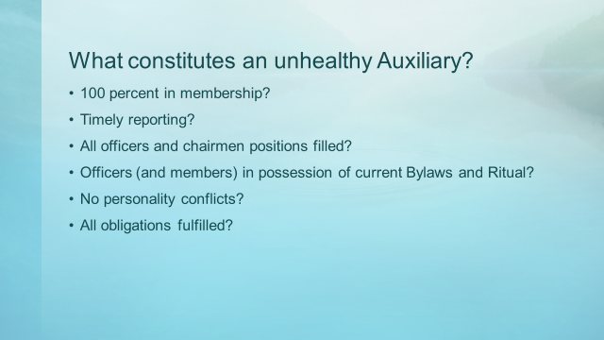

What constitutes an Unhealthy Auxiliary?
- 100 percent in membership?
- Timely reporting?
- All officers and chairmen positions filled?
- Officers (and members) in possession of current Bylaws and Ritual?
- No personality conflicts?
- All obligations fulfilled?

Wouldn’t it be wonderful if that indeed were the signs for an unhealthy Auxiliary. If that was the case, we wouldn’t be having this discussion today.

A healthy attitude is contagious but don’t wait to catch it from others…..be a carrier
Is your attitude worth catching?

Underline signs of concern?

With the aging membership, constraints of attending meetings, lack of participation, and repeat of officers’ year-after-year, it doesn’t always mean an Auxiliary is unhealthy but could be signs of underline concerns.

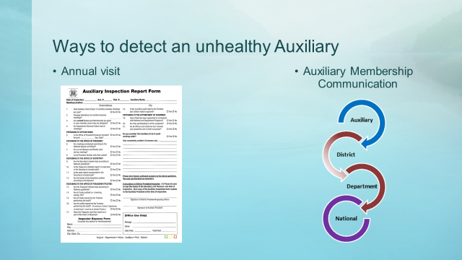

Ways to detect an unhealthy Auxiliary

One significant way of detecting an unhealthy Auxiliary is through the annual visits by the District President and/or his/her representative. This individual being honest on their report form and alerting the Department President of any concerns provides a focus on assigning assistance and tools to remedy the concern.

Another valuable way of detecting an unhealthy Auxiliary is through that Auxiliary’s membership and their communication to District and Department Leadership. There is no shame in asking for assistance or expressing concerns. This is a positive approach. By bringing to surface, an issue so it may be addressed before it festers into a full-blown problem is an attempt to become healthy again. This can ward off the negative impact that could take place if not handled.

What are signs that an Auxiliary may be entering an unhealthy state of mind?

- Lack of ability to elect of officers
  - Is there a lack of understanding of responsibilities?
    - Review Bylaws, Booklet of Instructions and Building on the VFW Auxiliary Foundation for guidance
  - Are members getting tired of holding office?
    - Offer to mentor the individual who may be willing to take on responsibility
    - Don’t disappear….fulfill your obligation to assist those that go after you.
    - Continue to serve with receiving and accepting assistance from others
  - Not enough participation to fulfill positions?
    - It’s not always ideal but members can hold multiple positions
    - The National Bylaws state:
      - No member shall hold two elective offices on the same level at the same time.
      - The member may hold one elective and one or more appointive offices on that level.
      - The exception to this rule being that a Trustee may hold another elective or appointive office other than President, Secretary or Treasurer. (Sec. 801 – Eligibility)
      - Nominating committees shall be permitted for Auxiliaries. (Sec. 804A – Auxiliary)
        - Reach out to all members to inquire their interest or availability to accept a position.
    - Educate
    - Support and mentor
    - We’re all in this together – You are a vital piece of the puzzle.

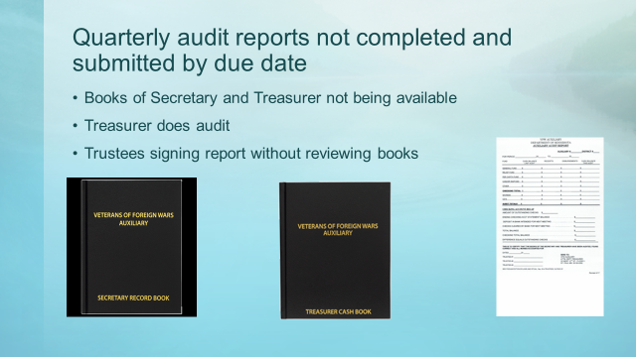

- Quarterly audit reports not completed and submitted by due date
  - Books of Secretary and Treasurer not being available
    - Set up time for all to meet to assure all books are available
    - Engage a pro-tem trustee if not all are available
    - Consider doing prior to regular business meeting
  - Treasurer does audit
    - Do not sign audit report unless process is completed by Trustees
  - Trustees signing report without reviewing books
    - Review responsibilities of the Trustees in Sec. 814 – Trustees, Duties of (All levels)
    - A trustee is a vital position to maintaining a healthy Auxiliary
      - Request guidance if unsure of process or concerns

- Unable to obtain a quorum for business meeting
  - It only takes 5
    - Utilize media resources, zoom, conference call, etc. Video conferencing or teleconferencing is permitted for members unable to attend the meeting provided a quorum is present at the meeting site
    - Evaluate day, time, location
  - Must hold at least 10 business meetings
    - For planning purposes, the Auxiliary may predetermine which two months a meeting may not be held, or reserve that option for inclement weather.

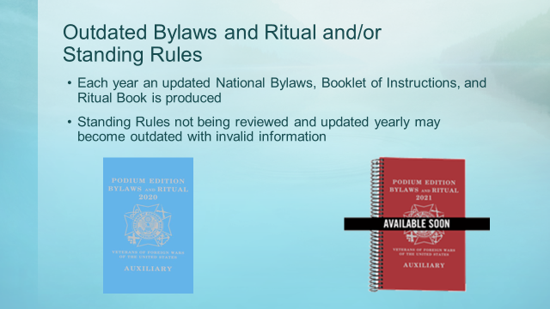

- Outdated Bylaws and Ritual and/or Standing Rules
  - Each year an updated National Bylaws, Booklet of Instructions, and Ritual book is produced.
    - Every Auxiliary should have in their possession a current edition.
    - The current edition is available for purchase by all members in good standing.
  - Standing rules not being reviewed and updated yearly may become outdated with invalid information.
    - Best practice should be to review yearly.

- Referencing outdated materials
  - General orders, chairmen bulletins, etc.
  - Destroy old forms
    - By not doing so, wrong information could be shared
      - Timelines not met
      - Inaccurate and incomplete forms
      - Misunderstanding of information
    - With the new program year comes new general orders, bulletins, forms

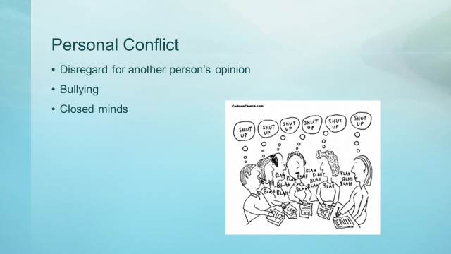

- Personal conflict
  - Disregard for another person’s opinion
  - Bullying
  - Closed minds
    - There is no room for petty jealousies
    - Every member deserves respect
    - Value each member’s contribution
    - We are not all going to agree all the time…that’s okay…but disagree in a respective manner
    - Stay off social media with your personal views of another member or Auxiliary business
    - Embrace the mentoring program and ideals to help diminish personal conflict
    - Most of all remember why you joined the organization

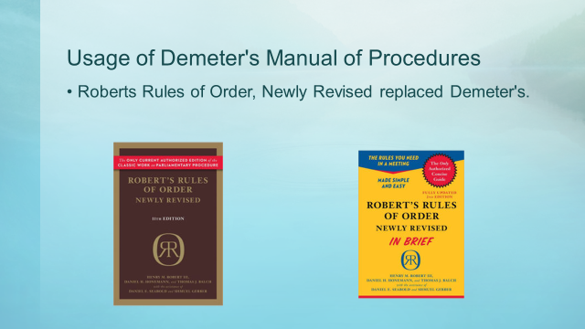

- Usage of Demeter’s Manual of Procedures
  - Roberts Rules of Order, Newly Revised replaced Demeter’s and shall govern on all points not covered in the Bylaws. (Sec. 916 – Rules of Order)

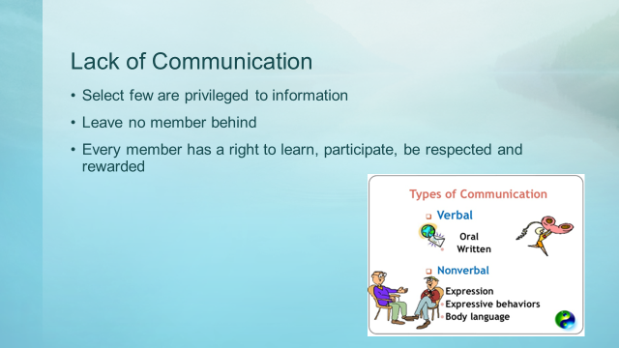

- Lack of Communication
  - Select few are privileged to information
    - All members should be aware of activities and business decisions of the Auxiliary
    - Final decisions should not be made outside the meeting room between a few cliché members
  - Leave no member behind
    - All members should be made aware of meeting dates, activities, volunteer opportunities
    - Create a monthly or quarterly communication whether written or verbal (call tree)
    - Obtain Auxiliary Facebook and or web page
    - Gather email addresses to remain in contact
  - Every member has a right to learn, participate, be respected and rewarded.
    - Make the most out of having a mentoring program and/or designated mentor
  - Types of communication
    - Verbal
      - Oral
      - Written
    - Nonverbal
      - Expression
      - Expressive behaviors
      - Body language
    - All types of communication should be set in a positive tone

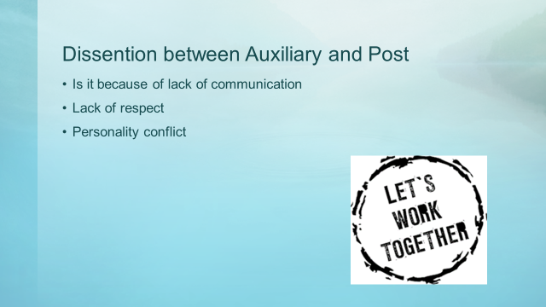

- Dissention between Auxiliary and Post
  - Is it because of lack of communication
  - Lack of respect
  - Personality conflict
    - If it weren’t for the Post….we wouldn’t be here
    - Set personalities aside and work towards our common goal…serving veterans, their families and the community
    - Respect the person who wore the uniform granting our freedom
    - Find common ground
    - Don’t meddle in Post business…..focus on Auxiliary business
    - Build trust between the Post and Auxiliary
    - Engage in joint project
    - Offer or request assistance for a positive outcome and experience

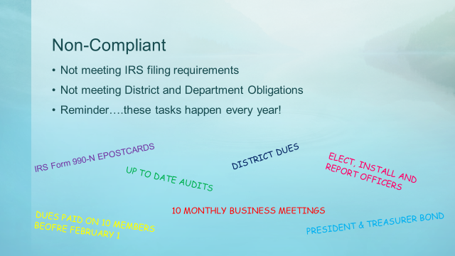

- Non-compliant
  - Not following Bylaws and Ritual
    - Department Secretary/Treasurer Laurie touched on the importance of the Bylaws
    - Review a section of the Bylaws at each meeting
    - Consider having a member chose a topic of interest
  - Not meeting IRS filing requirements
    - If you need assistance contact the Department Treasurer
  - Not meeting District and Department obligations
    - Include these obligations in your standing rules
  - Reminder…these tasks happen every year.

- Misuse of funds
  - Expending money without having passed a motion
    - Trustees should be reviewing expenditures when processing audit to assure proper authority was followed when funds were dispersed
  - Unaccounted cash receipts and disbursements
    - Receipts for both should be on file
  - Trustees should be comparing Secretary minutes and Treasurers report regarding expenditures
  - Special project funds
    - Make sure to have checks and balances in place
  - Funds belong to the Auxiliary – not an individual

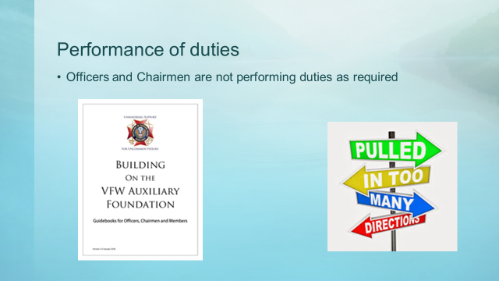

- Performance of duties
  - Officers and Chairmen are not performing duties as required
    - Is it a lack of interest or understanding the roles and responsibilities
      - Utilize the Building on the VFW Auxiliary Foundation Guidebooks
      - Revisit the Bylaws for position descriptions
    - Is it having too many responsibilities

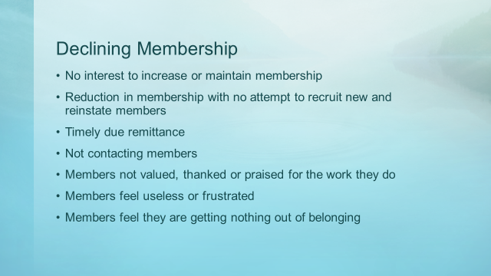

- Declining Membership
  - No interest to increase or maintain membership
  - Reduction in membership with no attempt to recruit new and reinstate members
    - WHY - - - WHY NOT reach out?
    - Review the membership wheel for eligibility
    - Revisit your own family member eligibility
    - Use community resources to get the message out about the Auxiliary
    - Review and disseminate brochures available from the Resource page
    - Ask….ask the question to familiar and unfamiliar individuals
  - Timely dues remittance
    - Utilize MALTA to transmit dues
    - Processing membership dues should not be held
    - Employ MALTA to generate membership dues reminders
  - Not contacting members
    - Sure way of eliminating volunteers, active members and valuable leaders
  - Members not valued, thanked or praised for the work they do
    - Find ways to positively recognize members for their contributions inside and outside the meeting room
      - Thank you note
      - Volunteer recognition event
      - Certificate recognizing member’s contribute – successful program
  - Members feel useless or frustrated
    - Encourage members to get involved in projects
    - Don’t wait for a member to volunteer …ASK if they would participate
  - Members feel they are getting nothing out of belonging (of the organization)
    - Give members responsibilities and tasks; team them up with experienced members.
    - Turn the table…identify the positive achievements due to their membership and value they bring
      - Supporting the veterans, family, communities

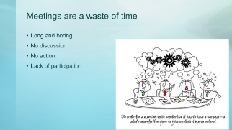

In order for a meeting to be productive, it has to have a purpose – a valid reason for everyone to give up their time to attend.

- Meetings are waste of time
  - Long and boring
    - Don’t have meetings just to meet
    - Have an agenda and purpose
    - Provide a clear direction
  - No discussion
    - Select few make decisions for the group outside the meeting room
      - Discussion is healthy but decisions are to be made by the body of the organization
    - Allow open dialogue where all opinions matter
      - Value the voice of the member
      - Discussion is healthy and necessary to understand the topic or action
  - No action
    - Create a positive atmosphere, ask questions and don’t discount another’s view or motion
    - Be the solution, not the problem
    - Every meeting should have some type of action needed. Approve bills, approve and/or plan a project, you get the picture.
  - Lack of participation
    - Members do little other than listen to leaders talk
    - A select group of individuals have all the power
    - Lack of encouragement for others to get involved
      - Structure meetings so they produce energy.
      - Allow everyone to have a chance to participate – not just a selective group.

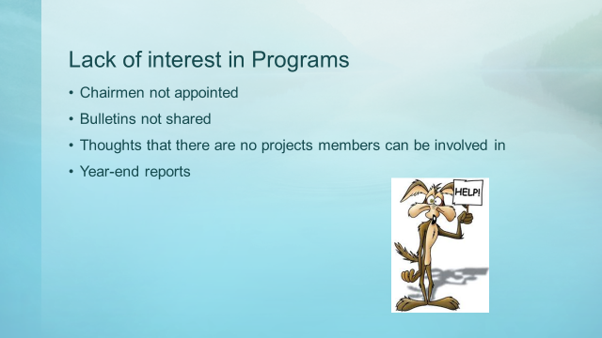

- Lack of interest in Programs
  - Chairmen not appointed
    - Seek volunteers or “ask” someone to chair
    - Identify a chairman’s responsibility
      - Monthly report
      - Instrumental in promoting and participating in project
      - Complete year-end report

  - Bulletins not shared
      - Ask President and/or Secretary to share and/or review during meeting
      - Subscribe to receive General Orders and bulletins via email (free)
      - Request paper copy of General Orders and bulletins for a fee of $35
      - Visit Department website where General Orders and bulletins are posted
      - Take the initiative on your own to find out what is happening.
  - Thoughts that there are no projects members can be involved in.
      - The Auxiliary provides a variety of interests through its programs
      - Provide a description of each program…find your members passion that fits in to a program
      - Utilize the materials provided by Department and National, especially the Resource page within Malta
      - With limited resources (funds, volunteers, etc.) address/plan for one project a month
  - Year-end reports
    - No participation
      - Every program should be able to come up with at least one item/activity to report
    - Plan for year-end reports throughout the year
      - Review Department and National Program books for information that will be requested

- Don’t think inside or outside the box….ELIMINATE THE BOX!

You only fail when you stop trying!

- Failure is not an option!
  - Tools are available within the Healthy Auxiliary Toolkit
    - Auxiliary Meeting Checklist
    - Healthy Communication Phone-Text Tree
    - RU Healthy Checklist – To Do’s and Deadlines
    - VFW Auxiliary Meeting Challenges and Solutions
    - VFW Auxiliary Member Questionnaire
    - VFW Auxiliary Sample Meeting Agenda
  - Online Academy
  - MALTA – Resource Page
    - Various promotional materials and forms
    - National Program book
  - National Programs BLOG
  - Facebook
  - Department Website
  - District and Department Leadership and Chairmen
  - Mentors!

Can my Auxiliary be healthy?
You know what….yes you can!

Positive questions are more likely to generate….
Positive energy that leads to….
People achieving positive results!

