Extension Program
Jane Ziebarth, Department of MN Chief of Staff
Fall Conference – September 26, 2020

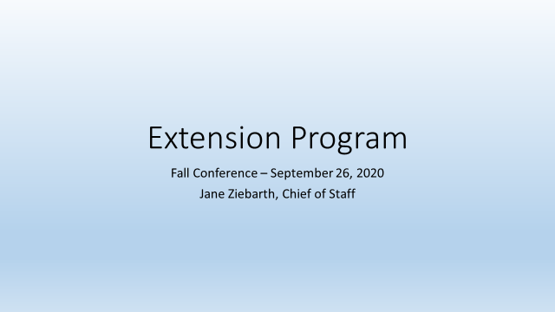

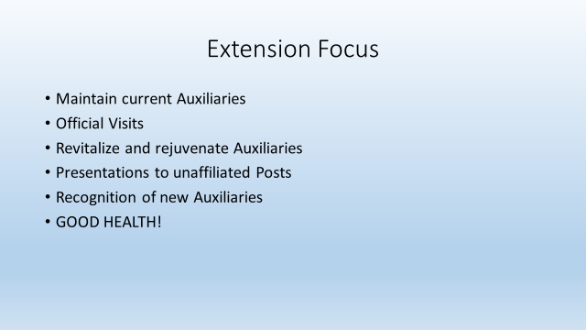

Extension Focus

The extension program continues to focus on maintaining current Auxiliaries, official visits, revitalize and rejuvenate Auxiliaries, presentations to unaffiliated Posts and welcome and recognize new Auxiliaries.

Obtaining and maintaining good health should be a top priority and something each member can influence!

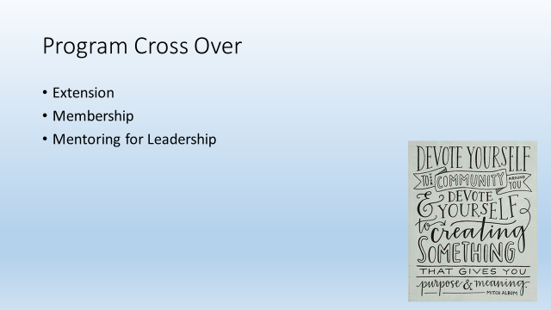

Program Cross Over

With this in mind the extension program crosses over to support the membership and mentoring for leadership programs. All are reaching out for members to create a heathy environment, maintain a positive experience and grow the organization.

In each scenario communication plays a key role towards success. We must continually be in contact with our members to assure we are meeting their needs, providing occasions for volunteering, listening to their suggestions and allow opportunities to move in to a leadership role whether it be an officer, program chairman or project chairman.

I view the Fall Conference as a resource to introduce new ideas, programs and venue to share.

With that, I offer you an opportunity to enhance the helpful Good Health Toolkit the National organization has provided to us over the years with a Minnesota VFW Auxiliary Member Survey.

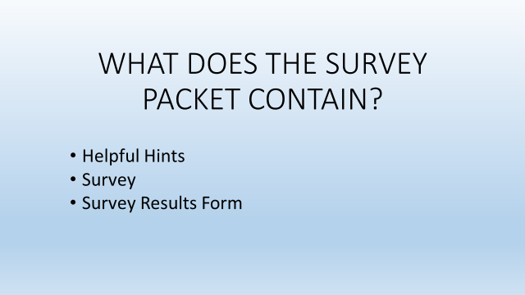

What does the survey packet contain?
- Helpful hints
- Survey
- Survey Results Form

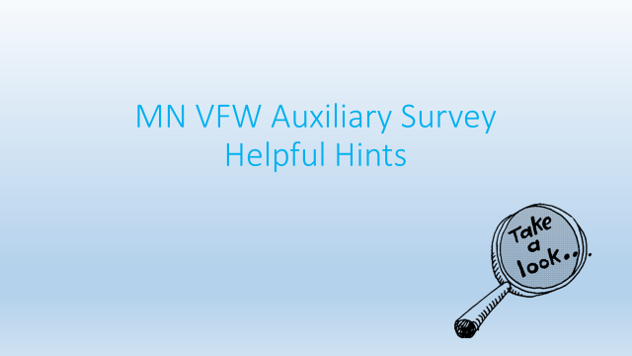

REVIEW HELPFUL HINTS

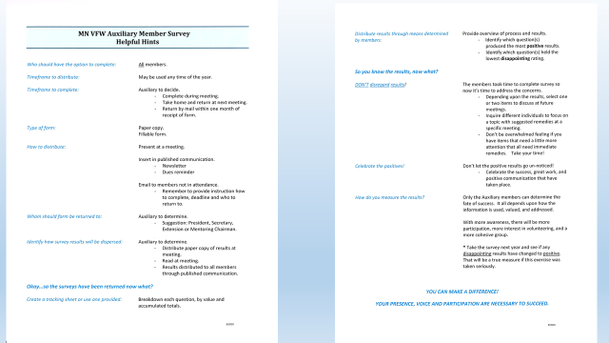

REVIEW SURVEY

This is a one page form that may be printed and share with your members. It is a filable form in the event you want to share with others to complete that way.

MN VFW Auxiliary Member Survey
How Are We Doing?
- One (1) page survey
- Fillable form
- 15 Questions
- Values are 1 to 5
  - 1 = Disappointing
  - 5 = Positive
- Area to make comments

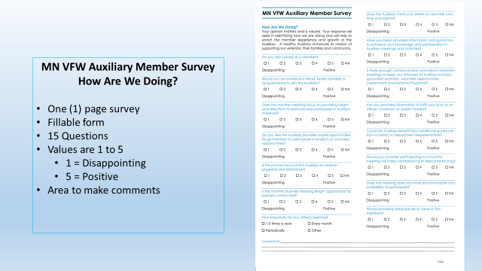

REVIEW SURVEY RESULTS FORM

MN VFW Auxiliary Member Survey
Results
- One (1) page to capture results
- Fillable form
- Ease of reviewing questions based upon values
  - Values are 1 to 5
    - 1 = Disappointing
    - 5 = Positive
- Collection of comments

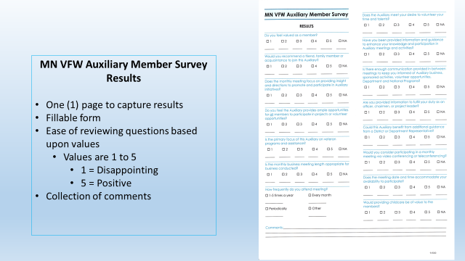

I will ask our webmaster Dave to upload to the Department Program resources following the Fall Conference.

There should be enough copies of the packet for each in attendance today to take back to the Auxiliary to share.

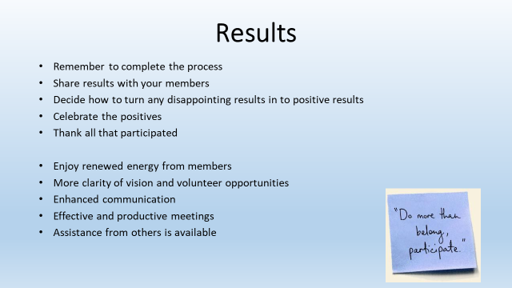

Results

I hope that this will help enhance participation and get a better understanding of what your members are thinking and how you react will determine its value.

- Remember to complete the process
- Share results with your members
- Decide how to turn any disappointing results in to positive results
- Celebrate the positives
- Thank all that participated
- Enjoy renewed energy from members
- More clarity of vision and volunteer opportunities
- Enhanced communication
- Effective and productive meetings
- Assistance from others is available

Please embrace this new survey and give it a try. The key is, to make it worth while, the process needs to be completed from beginning to end.

Awards For Members:

Personal gift to top three members who assisted in revitalizing/rejuvenating a struggling Auxiliary and utilized Building on the VFW Auxiliary Foundation in their efforts. Any member at any level of the organization can be nominated by the revitalized/rejuvenated Auxiliary. Award based upon National nomination form due to Department Chief of Staff by March 31, 2021

Awards For Auxiliaries:

- A gift and citation to top three Auxiliaries who used training and the Building on the VFW Auxiliary Foundation guidebooks to strengthen the Auxiliary. Year-end report detail will be used to determine this award.

- A gift and citation to top three Auxiliaries who used publicity who revitalized their Auxiliary. Year-end report detail will be used to determine this award.

Awards For Districts:

- A gift and a citation to the Deputy Chief of Staff in each membership group who provides the most assistance to revitalize Auxiliaries in her District. The Deputy Chief of Staff’s report and all other communications received throughout the year will be used to determine this award.

- A gift and citation to the Deputy Chief of Staff who has the best overall promotion of the Extension program during the program year. The Deputy Chief of Staff’s report and all other communications received throughout the year will be used to determine this award.

